**Bike-Share system**

**Team Members:** John Hawkins, Han Yang, Monica Ramos

**Project Description:**

Analyze the popularity of Bike Sharing system in Austin, TX

**Data Set:**

* <https://data.austintexas.gov/Transportation-and-Mobility/Austin-B-Cycle-Trips/tyfh-5r8s>
* <https://data.austintexas.gov/Transportation-and-Mobility/Austin-B-Cycle-Kiosk-Locations/qd73-bsdg>

**Project questions:**

1. Is Bcycle increasing in popularity through the years? **– John’s bar graph**
2. What are the high demand areas in the city? **– Han’s heapmap**
3. Type of membership offer and usage? **– Monica’s pie chart**
4. What are the high/low demand months and week days? **🡪 to be answer with John’s bar graph**
5. ???? what other questions we can make up???

**Exploration and cleaning:**

1. Using pandas: Explore, Clean, re-name, merge, fill up empty values
2. Import to SQLite:

to convert csv to sqlite: <https://pypi.org/project/csv-to-sqlite/>

more detailed instructions: <https://zblesk.net/blog/csv-to-sqlite/>

Monica’s test: **csv-to-sqlite -f Austin_B-Cycle_Kiosk_Locations.csv -o kiosk_Locations_MonicaTest.db**

**Extension file is .db**



1. View in DB Browser for SQLite

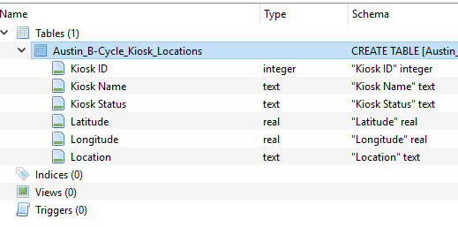

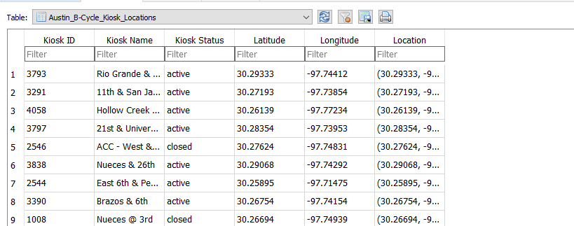

**Graphs and charts:**

1. Plotly chart for Bike sharing Monthly demand with drop menu to choose the year.

**Monthly Utilization of the bike sharing program – drop menu by year**

**John’s chart**

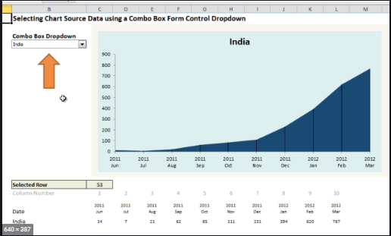

1. Leaflet.heat map of demand service in Austin, tX – **Most used stations – Han’s chart**

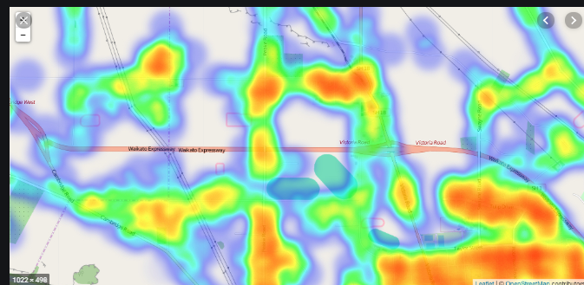

1. plotly Pie chart for **membership and usage – dropdown by year** – **Monica’s chart**

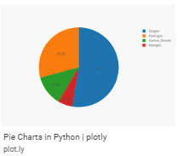

**One Page Website:**

<https://onepagelove.com/templates/free-templates/page/6>

**Out of scope:**

1. ~~Leafletjs Map with 5 station addresses with Highest demand in Austin, tx~~

